Workflow of Prepare Claim Request

Version: 0.1

Date: Nov 2018

|  |  |  |  |
| --- | --- | --- | --- |
| **Amendment History** | | | |
| Change Number | Revision Description | Revision / Version Number | Date |
| 1 | First Draft | V0.1 | 30 Nov 2018 |
|  |  |  |  |
|  |  |  |  |
|  |  |  |  |
|  |  |  |  |
|  |  |  |  |
|  |  |  |  |
|  |  |  |  |
|  |  |  |  |

Tables of Contents

1. Introduction 3

2. Create a claim request 4

3. Edit Claim request 6

Appendix 1. Attendant template 9

Appendix 2. Validation 10

# Introduction

This function allows claim preparer to create a new claim request, enquiry or edit existing claim request. System lists all claim request record which is under pending submit status with pagination. User can click the “**Action**” button to edit claim request record or click the “**Prepare Claim Request**” to create a new request.

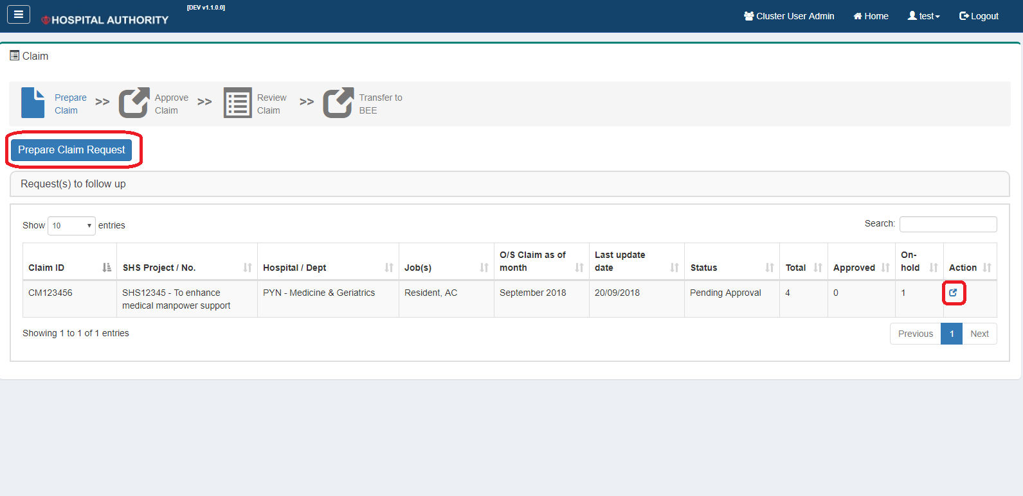

# Create a claim request

User need select project when create a claim request, after selected the project, related information also shown in screen. After created the request, system will redirect to edit mode for user download or upload attendant template.

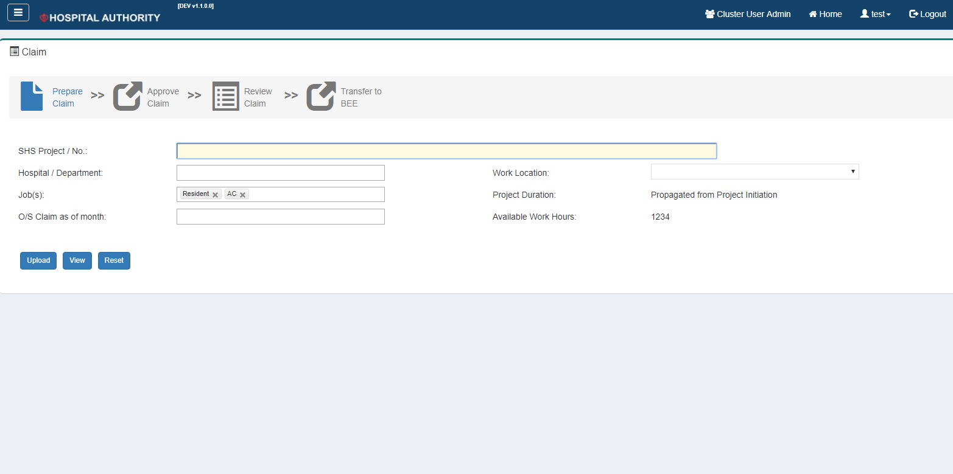

**Screen Item**

|  |  |  |
| --- | --- | --- |
| Field | Description | Field Type |
| Project/ No. | List all SHS Project | Dropdown  (Single selection) |
| Hospital / Department | Hospital/Department of the project | Label |
| Work Location | Work Location of the project | Label |
| Job(s) | Jobs of the project | Label |
| Project Duration | Duration of project | Label |
| Pay month | List of values from system go-live date to current system date.  Format as CCYYMM; default from System Date | Datetime Picker |
| Available work hours | Calculate and maintain from Project Initiation (i.e. approved work hours) and Duty Schedule (i.e. planned work hours from scheduled duty sessions).  Formula:  Available Work Hours = Approved Work Hours – Used Work Hours  (where Used Work Hours = planned work hours from scheduled duty sessions + realized work hour) | Label |

**Screen Button**

|  |  |
| --- | --- |
| Button | Description |
| Create | Create a new claim request, system will assign the claim id for the record. |
| Reset | Reset all value |

# Edit Claim request

This function allows user view claim request master record only, and user can download/upload attendant template, enquiry/delete uploaded attendant record.

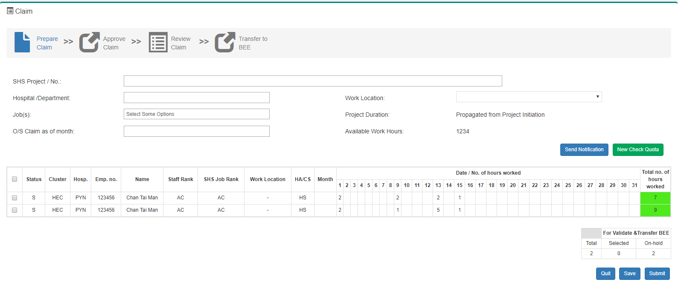

1. **Download Attendant Template**

* “**Download attendant template**” will be available for user download the template of attendant. The template file will be a “xlsx” format. For the details of attendant template, please refer.

1. **Upload Attendant Template**

* When user upload the attendant template, system will process the validation with the file (Validation please refer) and pop a dialog list the validation result. There are three types of the validation result, 1. **Passed**, 2. **Warning**, 3. **Error**. If the file has any record with “**Error**”, user need fix the problem in the file and then re-upload the file. If the file has record with “**Warning**”, system will pop a confirm dialog to do the double confirm before system accept the upload file record.
* If claim request already has attendant record, new upload record will override existing record.

1. **Enquiry uploaded Attendant record**

* After uploading successful, system would list a record in the data plane for user enquiry, but not allow user edit.

1. **Delete uploaded Attendant record**

* System allow user to clear all uploaded record.

**Screen Item (Master)**

|  |  |  |
| --- | --- | --- |
| Field | Description | Field Type |
| Project/ No. | Project of request | Label |
| Hospital / Department | Hospital/Department of the project | Label |
| Work Location | Work Location of the project | Label |
| Job(s) | Jobs of the project | Label |
| Project Duration | Duration of project | Label |
| Pay month | Pay month of claim request | Label |
| Available work hours | Available work hours of claim request | Label |

**Screen Item (Details)**

|  |  |  |
| --- | --- | --- |
| Items | Description | Item Type |
| Checkbox | For user select record to submit | Checkbox |
| Status | S = Submit, P = Pending Submit | Label |
| Cluster | Retrieve from database base on assignment no. | Label |
| Hosp. | Retrieve from database base on assignment no. | Label |
| Emp. No. | Retrieve from database base on assignment no. | Label |
| Assignment No. | Retrieve from upload file | Label |
| Name | Retrieve from database base on assignment no. | Label |
| Staff Rank | Retrieve from database base on assignment no. | Label |
| SHS Job Rank | Retrieve from database base on assignment no. | Label |
| Job | Retrieve from upload file | Label |
| Work Location | Retrieve from upload file | Label |
| HA/CS | Retrieve from database base on assignment no. | Label |
| Hour Type | Retrieve from upload file | Label |
| COA Inst | Retrieve from upload file | Label |
| COA Fund | Retrieve from upload file | Label |
| COA Section | Retrieve from upload file | Label |
| COA Analytic | Retrieve from upload file | Label |
| COA Type | Retrieve from upload file | Label |
| Earned Month | Retrieve from upload file | Label |
| Date/No. of hours worked | Retrieve from upload file | Label |
| Total no. of hours worked | Sum of Date/No. of hours worked | Label |

**Screen Button**

|  |  |
| --- | --- |
| Button | Description |
| Download Attendant Template | For user download the attendant template. |
| Upload | For user upload the attendant template. |
| Show/Hide COA Details | Show/Hide COA details in Details part. |
| Show/Hide No. of Hours worked details | Show/Hide No. of Hours worked details in Details part. |
| Clear | Clear all uploaded record. |

# Appendix 1. Attendant template

###### Header

|  |  |
| --- | --- |
| Field | Description |
| Project/ No. | Pre-filled claim request information. |
| Project Type | Pre-filled claim request information. |
| Hospital/Department | Pre-filled claim request information. |
| Work Location | Pre-filled claim request information. |
| Pay Month | Pre-filled claim request information. |

###### Details

|  |  |
| --- | --- |
| Field | Description |
| Assignment No. |  |
| Name |  |
| Work Location |  |
| Job |  |
| Hour type | Standard / Non-Standard / Night |
| COA Inst |  |
| COA Fund |  |
| COA Section |  |
| COA Analytic |  |
| COA Type |  |
| Earned Month | Format CCYYMM |
| Date / No. of hours worked |  |
| Total | Sum of Date / No. of hours worked |

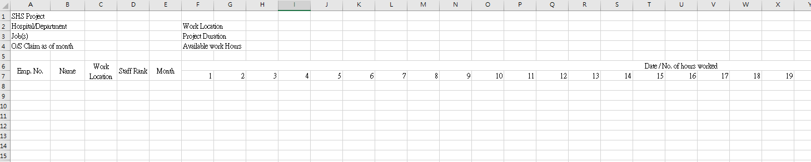

# Appendix 2. Validation

When upload the template, system will do a validation checking, there are three types of the validation: 1. **Passed**, 2. **Warning**, 3. **Error**.

After upload the file, system will pop a dialog to show the validation result with type equal “**Warning**” or “**Error**”. If the file has any record with “**Error**”, user need fix the problem in the file and then re-upload the file. If the file has record with “**Warning**”, system will pop a confirm dialog to do the double confirm before system accept the upload file record.

Field Validation

|  |  |  |  |
| --- | --- | --- | --- |
| Field | Validation | Type | Error Message |
| Assignment No. | Mandatory | Error | Line #line Assignment number cannot be empty. |
| Name | Mandatory | Error | Line #line Name cannot be empty. |
| Work Location | Mandatory | Error | Line #line Work Location cannot be empty. |
| Hour Type | Mandatory | Error | Line #line Hour Type cannot be empty. |
| Hour Type | Equal “Standard” or “Non-Standard” or “Night” | Error | Line #line Hour Type must equal to “Standard” or “Non-Standard” or “Night”. |
| COA Inst | If Input, max length is 3 | Error | Line #line COA Inst #value can’t longer than 3. |
| COA Fund | If Input, max length is 2 | Error | Line #line COA Fund #value can’t longer than 2. |
| COA Section | If Input, max length is 7 | Error | Line #line COA Section #value can’t longer than 7. |
| COA Analytic | If Input, max length is 5 | Error | Line #line COA Analytic#value can’t longer than 5. |
| COA Type | If Input, max length is 2 | Error | Line #line COA Type #value can’t longer than 2. |
| Earned Month | Mandatory | Error | Line #line Earned Month cannot be empty. |
| Earned Month | Within 1 to 12 | Error | Line #line Earned Month #value must within 1 to 12. |
| Date/ No. of Hours Worked | Allow 1 decimal place | Error | Line #line Date/ No. of Hours Worked #value only allow 1 decimal place. |
| Date/ No. of Hours Worked | Smaller than 24 | Error | Line #line Date/ No. of Hours Worked #value must smaller than 24. |

Cross-fields Validation

|  |  |  |  |
| --- | --- | --- | --- |
| Field | Validation | Type | Error Message |
| Date / No. of hours worked | At least fill one date | Error | Line #line as least fill one date. |
| Assignment No. & Work Location & Job  & Hour Type  & Earned Month | Not allow duplicate **Assignment** No, Work Location, Job, Hour Type and Earned Month | Error | Duplicate record in #line. |

Database Validation

|  |  |  |  |
| --- | --- | --- | --- |
| Field | Validation | Type | Error Message |
| Name | Not match with name which is retrieved from database by the Assignment No | Warning | Line #line name #recordName not match with database name #databaseName |